Bash Scripts:

Script 1:

#!/bin/bash

# Database credentials

DB_USER="HR"

DB_PASSWORD="hr"

DB_NAME="HR"

TIMESTAMP=$(date '+%Y%m%d_%H%M%S')

# Create backup using expdp (Data Pump)

expdp $DB_USER/$DB_PASSWORD DIRECTORY=data_pump_dir DUMPFILE=backup_$TIMESTAMP.dmp LOGFILE=backup_$TIMESTAMP.log

# Check if backup was successful

if [ $? -eq 0 ]; then

echo "Database backup completed successfully."

else

echo "Error: Database backup failed."

Fi

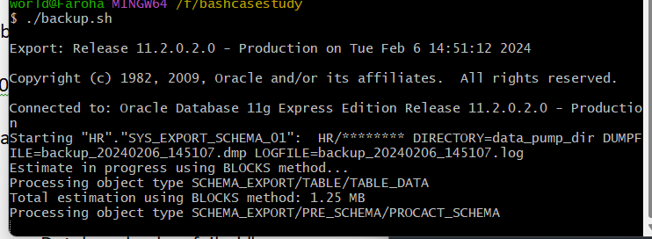

Script 2:

#!/bin/bash

# Set the threshold for disk usage percentage

THRESHOLD=20

# Check disk space

DISK_USAGE=$(df -h / | awk 'NR==2 {print $5}' | cut -d'%' -f1)

# Compare with the threshold

if [ "$DISK_USAGE" -gt "$THRESHOLD" ]; then

# Send email alert

echo "ALERT: Disk usage exceeded $THRESHOLD% - Current usage: $DISK_USAGE%"

else

echo "Disk usage is within the threshold: $DISK_USAGE%"

fi

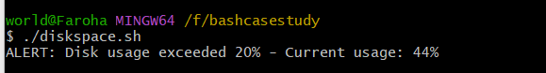

Script 3:

#!/bin/bash

TotalSpace=$(systeminfo | grep 'Total Physical Memory' | awk '{ print $4 }' | tr -d ',')

AvailableSpace=$(systeminfo | grep 'Available Physical Memory' | awk '{ print $4 }' | tr -d ',')

UsedSpace=$((TotalSpace - AvailableSpace))

echo "Used Space = $UsedSpace MB"

Percentt=$(((AvailableSpace*100)/UsedSpace))

THRESHOLDD=20

if [[ $Percentt -gt $THRESHOLDD ]]; then

echo "ALERT !! Memory consumption has exceeded $THRESHOLDD% , Current Consumption : $Percentt% , $(date)"

else

echo "Memory consumption is safe and within the threshold : $Percentt% , $(date)"

